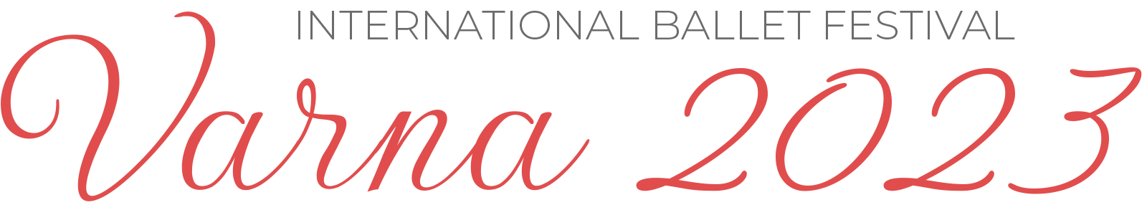

Entry Form for Master Classes
Outside of the Festival Program

- Name……………………………………………………………….………….

- Ballet……………………………………………………………….………….

- Age group: from 7 to 13 years: ................ / from 14 to 21 years: ....................

Telephone: ……………………….… e-mail: ……………….……...…...........

Please fill in and send this form to: varna.ballet@abv.bg

Age Group From 7 to 13 years:

- Classical Exercise – Diana White, USA – prima of the New York City Ballet, teacher
- Repertoire of Balanchine – Momchil Mladenov, China – NYB premier soloist, teacher at National School - Beijing
- Repertoire of Bournonville, Danish school – Petya Ivieva, Finland – Prima of the Finnish National Ballet, teacher at the National Ballet School of Finland
- Typical Dance Techniques – Antoaneta Aleksieva – choreographer and pedagogue in the National Dance Art School

Age Group From 14 to 21 years:

- Classical Exercise – Momchil Mladenov, China – NYB premier soloist, teacher at National School - Beijing
- Repertoire of Balanchine – Diana White, USA – prima of the New York City Ballet, teacher
- Pointe Exercise, Reportoire – Kristina Grigorova, Italy
- Contemporary – Isis Calil De Albaquerque, Germany

1 master class – 2 academic hours x 45 min.

